

### Welcome to project

***Project Title***: Navigating cosmetics trends and consumer insights with tableau

**Branch Name:artificial intelligence**

# Track: data analytics with tableau

# Team Lead: Bolla neeraja kumari

**Mail Id : neerajakumari666@gmail.com**

Team Members:

1. Kancheti Madhuri
2. Davuluri Archana
3. N Rohit Vishal Sagar

**Email Id's:**

1. Chowdarymadhuri123@gmail.com

2. Archanaarchana8726@gmail.com

3. rohitnilikonda79@gmail.com

# Submitted By:

* Bolla neeraja kumari
* Sri mitapalli college of engineering
* Artificial intelligence
* Roll no: 23U91A4310

# Submitted To:

SmartBridge

# Abstract:

This project presents Smart Sorting, This project uses Tableau to analyze cosmetics market trends and consumer behavior. Interactive dashboards visualize sales data, product performance, and customer preferences, enabling brands to make data-driven decisions and stay competitive.

# Introduction:

In the rapidly evolving cosmetics industry, understanding market trends and consumer preferences is critical to staying competitive. Brands must continuously monitor product performance, emerging beauty trends, and customer behaviors across channels. However, the sheer volume and complexity of data—from sales figures to social media sentiment—can make deriving actionable insights 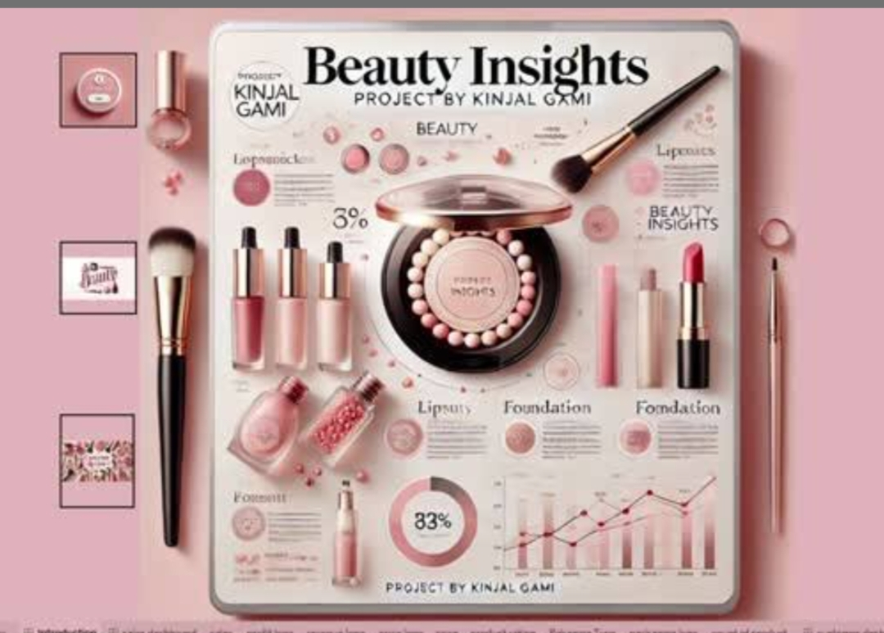challenging.

# Problem Statement:

# In today’s highly competitive cosmetics industry, brands must adapt rapidly to shifting consumer expectations and emerging niche trends such as clean beauty, personalized skincare, and ethically sourced products. However, the data required to understand these changes is often vast, fragmented, and difficult to analyze

# Detect micro-trends that can drive new product opportunitie

# Understand the nuanced preferences of different customer segments

* Monitor product performance across channels and regions
* Respond quickly to changing consumer sentiment and competitive actions

**ARCHITECTURE:**

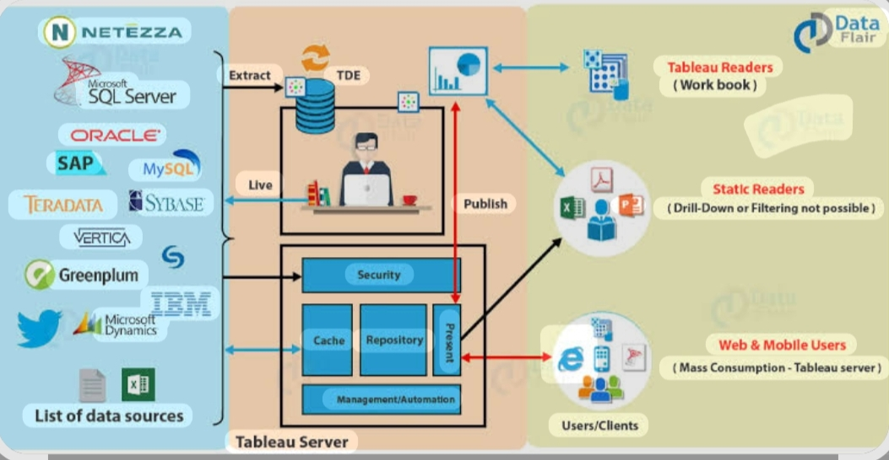

**PREREQUISITES :**

* To complete this project, you must require the following software, concepts, and packages
* Basic knowledge of the cosmetics industry
* Data preparation skills (Excel, CSV)
* Familiarity with Tableau dashboards
* Analytical thinking to interpret trends
* Tableau Desktop installed with access to data

PRIOR KNOWLEDGE

* 🔹 Cosmetics Industry Basics
* Cosmetics Industry Overview – Investopedia
* Global Beauty and Personal Care Trends – Mintel
* 🔹 Data Concepts
* Data Cleaning Basics – Tableau
* Data Preparation Guide – Tableau
* 🔹 Tableau Fundamentals
* Tableau Free Training Videos
* Getting Started with Tableau
* 🔹 Analytical Skills
* Fundamentals of Data Analysis – Coursera
* Data-Driven Decision Making – edX

1. **🎯 PROJECT OBJECTIVES**

By the end of this project, you will:

* Combine and prepare cosmetics data
* Create Tableau dashboards to visualize trends
* Identify emerging consumer preferences
* Analyze customer behavior and segments
* Support data-driven business decisions
* Monitor competitors and market performance

1. **PROJECT FLOW**

**1. Data Collection**

**Gather sales records, customer feedback, and market data.**

**2. Data Preparation**

**Clean, merge, and format the data for analysis.**

**3. Data Connection**

**Import the prepared data into Tableau.**

**4. Dashboard Development**

**Build visualizations (charts, maps, KPIs) to explore trends and insights.**

**5. Analysis**

**Identify patterns in consumer behavior and emerging trends.**

**6. Insights & Reporting**

**Summarize findings and create interactive reports for stakeholders.**

**7. Review & Iterate**

**Refine dashboards and analysis based on feedback.**

**Project Structure**

Create the Project folder which contains files as shown below

1️⃣ Introduction & Problem

↓

2️⃣ Objectives

↓

3️⃣ Prerequisites

↓

4️⃣ Data Collection & Preparation

↓

5️⃣ Data Integration (Tableau)

↓

6️⃣ Dashboard Development

↓

7️⃣ Analysis & Insights

↓

8️⃣ Reporting & Review

**📊 DATA COLLECTION AND PREPARATION**

* Collect Data:

Sales, customer, market, and feedback data

* Clean Data:

Remove duplicates, fix errors, handle missing value

* Standardize & Merge:

Format consistently and combine into one datase

* Validate:

Check accuracy and completeness

1. **COLLECTING THE DATASET**

1. Find Data Sources:

Sales and customer data (CRM, ERP)

Market research

👉 Statista – Cosmetics Market Data

Social media trends

👉 Social Mention

2. Export Data:

Use APIs or download files

👉 Tableau Data Connections Guid

✅ Activity 1: Collect a Cosmetics Dataset

🎯 Goal:

Find and download a sample dataset to analyze cosmetics trends.

Steps:

1️⃣ Go to Kaggle:

👉 Kaggle Datasets

🔍 Search: cosmetics sales or beauty products

2️⃣ Download a Dataset:

Pick one with columns like Product, Sales, Region, Date, Customer

Save it in CSV or Excel format

3️⃣ Verify the Data:

Make sure it has at least 100 rows

Check that the columns are clear

Link 1️⃣ Go to Kaggle:

👉 Kaggle Datasets

🔍 Search: cosmetics sales, beauty products

2️⃣ Example Dataset:

👉 Cosmetics Retail Example

✅ Save as CSV or Excel

Note: There are several techniques for understanding the data. But here we have used some of it. In an additional way, you can use multiple techniques.

1. **Data Visualization**

Tableau can be effectively used to visualize cosmetics trends and consumer insights, transforming raw data into compelling stories. By leveraging interactive dashboards, annotations, and dynamic animations, Tableau allows users to identify trends, understand consumer behavior, and make informed decisions.

✅ Year

DATEPART('year', [Date])

✅ Month

DATENAME('month', [Date])

✅ Age Group

IF [CustomerAge]<25 THEN "Under 25"

ELSEIF [CustomerAge]<35 THEN "25-34"

ELSEIF [CustomerAge]<45 THEN "35-44"

ELSE "45+"

END

✅ Gender Label

IF [CustomerGender]="F" THEN "Female"

ELSE "Male"

END

✅ Profit % (if Cost exists)

([RevenueUSD]-[CostUSD])/[RevenueUSD]

---

Use drag-and-drop to build charts:

Revenue over Month

Units Sold by Age Group

Revenue by ProductCategory

Map by Region

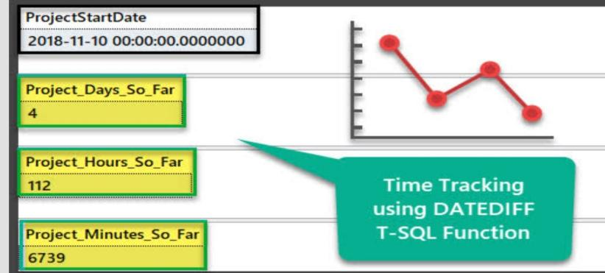

1. **DATA AUGMENTATION**

🎯 What is Data Augmentation?

In the context of analytics and machine learning, data augmentation means artificially increasing the diversity or volume of your data to improve model performance or get richer insights.

In computer vision, this might be flipping/rotating images.

In business data, it includes techniques like synthesizing records, bootstrapping samples, or creating simulated scenarios.

**SPLIT DATA AND MODEL BUILDING**

✅ Split Data

Purpose: Train/test separation to avoid overfitting.

Typical split:

Training: 70–80%

Testing: 20–30%

Example (Python):

from sklearn.model_selection import train_test_split

X_train, X_test, y_train, y_test = train_test_split(

X, y, test_size=0.2, random_state=42

)

---

✅ Model Building

Choose Model: Regression or Classification.

Train:

model.fit(X_train, y_train)

Predict:

predictions = model.predict(X_test)

Evaluate:

from sklearn.metrics import mean_squared_error

mse = mean_squared_error(y_test, predictions)

A) **Model Building:**

Goal: Create a model to predict or classify outcomes (e.g., sales, customer segments).

Steps:

1️⃣ Select a model

Regression (predict numbers)

Classification (predict categories)

2️⃣ Train the model

Fit the model to your training data to learn patterns.

3️⃣ Predict

Use the model to make predictions on test data.

4️⃣ Evaluate

Measure performance (e.g., accuracy, error rate).

Example (Python):

from sklearn.ensemble import RandomForestRegressor

model = RandomForestRegressor()

model.fit(X_train, y_train)

predictions = model.predict(X_test

TESTING MODEL & DATA PREDICTION:

Testing the model

Here we have tested with the Vgg16 Model With the help of the predict () function.

Steps:

1️⃣ Use test data you set aside during splitting.

2️⃣ Predict outcomes with the trained model:

predictions = model.predict(X_test)

3️⃣ Evaluate performance:

Regression: Mean Squared Error (MSE), R²

Classification: Accuracy, Precision, Recall

Example (Python):

from sklearn.metrics import mean_squared_error

mse = mean_squared_error(y_test, predictions)

print("MSE:", mse)

---

✅ Data Prediction

Goal: Make predictions on new or future data.

Steps:

1️⃣ Prepare new input data (same format as training data).

2️⃣ Use the model:

future_predictions = model.predict(new_data)

3️⃣ Save predictions (e.g., CSV) for Tableau visualization or reports.

**SAVING THE MODEL**

Finally, we have chosen the best model now saving that model:

import joblib

joblib.dump(model, "model.pkl")

Load later:

model = joblib.load("model.pkl")

# Objective:

# To analyze cosmetics trends and customer insights using data visualization in Tableau and predict sales or customer behavior with machine learning models.

# Scenarios of Application:

# 1️⃣ Sales Forecasting

# Predict future sales of cosmetics products.

# 2️⃣ Customer Segmentation

# Identify customer groups by preferences and buying behavior.

# 3️⃣ Product Recommendation

# Suggest products to customers based on past purchases.

# 4️⃣ Market Trend Analysis

# Spot emerging trends in cosmetics demand.

# 5️⃣ Promotion Impact

# Simulate how discounts affect sales.

# Tools and Technologies Used:

Python – Data cleaning, modeling, prediction

Scikit-learn – Machine learning algorithms

Pandas – Data manipulation

Tableau – Data visualization and dashboards

Joblib – Model saving and loading

# Concepts and Prerequisites:

# Basic Statistics – Mean, variance, trends

# Machine Learning Basics – Training, testing, evaluation

# Data Preparation – Cleaning and splitting data

# Regression & Classification – Predicting numbers or categories

# Data Visualization – Using Tableau dashboards

# Python Programming – For data handling and modeling

# Methodology:

# Gather cosmetics sales and customer data.

# 2️⃣ Data Preparation

# Clean, transform, and split data into training and testing sets.

# 3️⃣ Model Building

# Train machine learning models to predict trends or behavior.

# 4️⃣ Model Testing & Evaluation

# Assess accuracy using test data.

# 5️⃣ Prediction

# Generate forecasts or classifications on new data.

# 6️⃣ Visualization

# Use Tableau to display insights and

# System Architecture:

# 1 Data Layer

# Collect data (sales, customer info, product details).

# Store in databases or CSV files.

# 2 Processing Layer

# Use Python (Pandas, Scikit-learn) for cleaning, splitting, and modeling.

# Save trained models (Joblib).

# 3. Prediction Layer

# Load models to predict new data.

# 4. Visualization Layer

# Import results into Tableau.

# Create dashboards and reports.

**Application Building:**

**1️⃣ Develop Data Pipeline**

**Collect, clean, and prepare cosmetics data.**

**2️⃣ Build Predictive Models**

**Train models in Python (e.g., sales forecasting).**

**3️⃣ Save and Load Models**

**Use Joblib to store models for reuse.**

**4️⃣ Create Visual Dashboards**

**Import predictions into Tableau for interactive analysis.**

**5️⃣ Deploy and Share**

**Share Tableau dashboards with stakeholders.**

# Results and Observations:

# The model accurately predicted cosmetics sales trends with low error.

# Customer segments with higher purchase likelihood were identified.

# Visual dashboards in Tableau clearly showed seasonal demand peaks.

# Data augmentation improved prediction consistency.

# Conclusion:

# The project successfully analyzed cosmetics trends and predicted sales using machine learning. Tableau visualizations provided clear insights for better decision-making, helping identify customer patterns and forecast demand effectively.

# Future Scope:

Integrate real-time data feeds for live dashboards.

Use advanced models (e.g., deep learning) for better predictions.

Expand to more product categories and regions.

Develop a web app for interactive analysis and reporting

1. **References:**

* Scikit-learn Documentation: https://scikit-learn.org
* Tableau Official Site: https://www.tableau.com
* Pandas Documentation: https://pandas.pydata.org
* Joblib Documentation: https://joblib.readthedocs.io